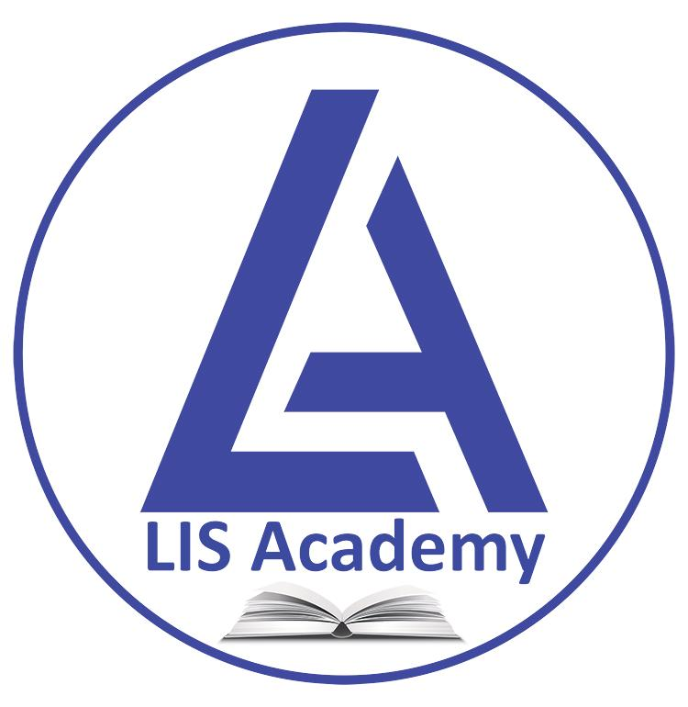

LIS Academy

Library Technology Training Programs

LIS Academy conducts Offline and Online Training Programs for LIS students, teachers, librarians, and information professionals. The programs focus on skill development, library technologies, and emerging trends in Library & Information Science.
Offline programs are organized in collaboration with educational institutions and libraries to provide practical exposure and hands-on learning. Online programs, webinars, and workshops ensure wider participation and continuous professional development.
Some of the major Library Technology Training Programs offered by LIS Academy are as follows:

1. Library Automation Software Training (KOHA)
Comprehensive hands-on training on KOHA Integrated Library Management Software for automating circulation, cataloguing, acquisitions, serial control, and OPAC services. The program enables libraries to efficiently manage their day-to-day operations using open-source technologies.

2. Digital Library Development (DSpace / Greenstone)
Training on designing, developing, and managing digital libraries using platforms such as DSpace and Greenstone. Participants learn digital collection creation, metadata management, content organization, and online access systems.

3. Institutional Repository Management
Focused training on establishing and maintaining institutional repositories for theses, dissertations, research papers, and faculty publications. The program covers repository workflows, metadata standards, and open-access dissemination practices.

4. Library Website & Portal Development
Practical guidance on creating dynamic library websites and user-friendly information portals. The training includes content management systems, web design basics, digital services integration, and online user engagement tools.

5. Open Source Library Technologies
Exposure to various open-source tools and platforms used in modern libraries for automation, discovery, digital preservation, and resource sharing. Participants gain practical skills in adopting cost-effective technology solutions.

6. RFID & Smart Library Systems
Training on Radio Frequency Identification (RFID) technologies and smart library applications for self-check-in/check-out, security, inventory management, and automated circulation services. The program introduces smart library infrastructure and implementation practices.

7. E-Resource Management Techniques
Covers the acquisition, organization, access management, and usage analysis of electronic resources such as e-journals, databases, and e-books. Participants learn licensing, authentication systems, and digital access management.

8. Library Networking & Cloud-Based Services
Training on library networking concepts, resource sharing models, and cloud-based library solutions. The program introduces collaborative platforms, remote access systems, and cloud-hosted library services for modern institutions.

9. Research Support Tools & Reference Management Software
Hands-on sessions on tools such as Zotero, Mendeley, EndNote, and academic research platforms. The training helps professionals support researchers in citation management, literature review, and scholarly communication.

10. Plagiarism Detection & Academic Integrity Tools
Training on plagiarism detection software, originality checking systems, and academic integrity practices. Participants learn methods for ethical research support and institutional compliance with scholarly standards.

11. Metadata Standards & Cataloguing Technologies
Detailed orientation on metadata creation, bibliographic standards, and digital resource description practices. The program covers Dublin Core, MARC21, metadata interoperability, and automated cataloguing systems.

12. MARC21, RDA & Library Classification Tools
Specialized training on modern cataloguing standards including MARC21 and Resource Description & Access (RDA). Participants also learn practical applications of DDC, UDC, and subject indexing tools.

13. Digital Preservation & Archiving Techniques
Training on preserving digital content, institutional records, manuscripts, and archival collections using modern preservation standards and software tools. The program focuses on long-term accessibility and digital sustainability.

14. Data Analytics & AI Applications in Libraries
Introduction to data-driven library services and the use of Artificial Intelligence tools in information management. Participants explore analytics for user behavior, resource utilization, and intelligent library services.

15. Information Retrieval & Discovery Tools
Training on search technologies, discovery services, indexing systems, and advanced information retrieval techniques. The program enhances skills in improving access to scholarly and digital information resources.

16. Web 2.0 & Social Media Applications for Libraries
Practical sessions on using blogs, social media platforms, podcasts, and collaborative technologies for library promotion and user engagement. The program supports digital outreach and community interaction strategies.

17. Mobile Library Applications & Digital Services
Training on mobile-enabled library services, digital access platforms, and mobile applications for users. Participants learn techniques for providing library services through smartphones and portable devices.

18. ICT Skills for Library Professionals
A foundation program covering essential Information and Communication Technology skills required for modern library professionals. Topics include office productivity tools, internet technologies, digital communication, and basic networking.

19. Emerging Technologies in Libraries
An overview of next-generation technologies such as Artificial Intelligence, Blockchain, Internet of Things (IoT), Virtual Reality, and machine learning applications in libraries. The program prepares professionals for future-ready library services.

20. Hands-on Workshops on Modern Library Practices
Short-term practical workshops focusing on current trends, innovative technologies, and real-time applications in libraries. These workshops emphasize experiential learning and skill enhancement for working professionals

